**School Management System**

V1.0

# Login Screen

At start, Login screen should open. User should provide a valid User Name & Password to login. There should be an option (“New User?”) which will redirect to user (“New User”) screen. If User is not valid, User should be shown a message “Invalid User Name/Password”. If User is valid, User should redirect to home screen based on account type.

# New User screen

Following fields should be available

* First Name (Text box)
* Last Name (Text box)
* Gander (Male, Female radio buttons)
* Date of Birth (Textbox)
* City (drop down list with three options Lahore, Karachi, ISB)
* Account Type (drop down list with two options Student, Teacher)
* Login (Text box)
* Password (Password box)
* Confirm Password (Password box)

# Global Layout after Authentication

Once user is logged in, a global layout should be as following

* At top there should be logo
* After logo there should be a top menu
* At left, there should be a sub menu
* At right, a column should be left (which child pages can use if want)
* Footer should show some copy right message

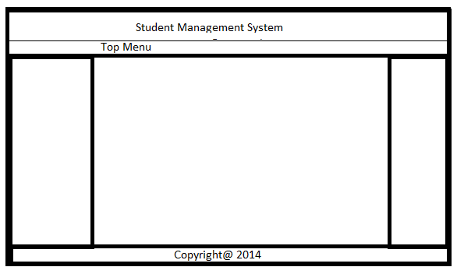

# Top Menu

If user type is ‘Student’ following are the options to show in Top Menu

* Home
  + Will redirect user to dashboard
* Profile
* Change Password
* Lecture Schedule
* Sign out

If user type is ‘Teacher’ following are the options to show in Top Menu

* Home
  + Will redirect user to dashboard
* Profile
* Change Password
* Course Management
* Lecture Scheduling
* Sign out

# Student Home Screen

Left menu should show all courses as hyperlink, user can click on course link and that course detail will be shown in middle box

